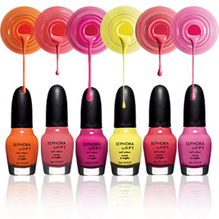

Phone: (781)647-5402

Here you will find the BEST deals!!!

# Nail Salon

**Janet’s Place**

Prices at other Nail Salons range anywhere from $10-$40 or ever to $60 dollars but here a manicure is $5 and so is a pedicure!!!

91 Lake Street

Waltham, Ma 02451

Phone: (781)647-5402

[Janetorozco82@yahoo.com](mailto:Janetorozco82@yahoo.com)

[www.JanetsNailSalon.weebly.com](http://www.JanetsNailSalon.weebly.com)

#### Best Deals Ever

Janet’s Place

#### NAIL DESIGNS Pick one, Pick some!

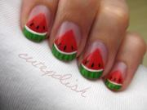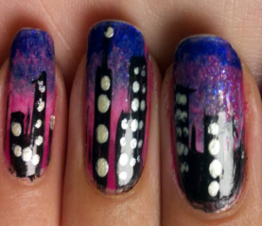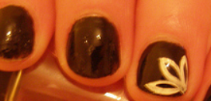 

  





**There’s more where this came from!!!!**